### **A049 | AYESHA MULLA | 70612300025 | MCA**

### **Step 1: Install Terraform**

Make sure you have Terraform installed on your machine. You can download it from terraform.io.

### **Step 2: Create the Terraform Configuration**

Create a new directory for your Terraform project and navigate into it:

mkdir terraform-file-structure

cd terraform-file-structure

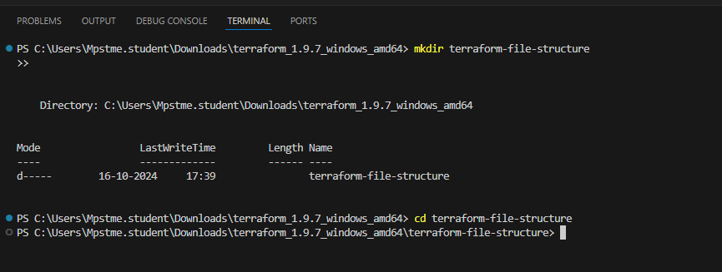

Create a file named main.tf and add the following code:

terraform {

required_providers {

local = {

source = "hashicorp/local"

version = "~> 2.1"

}

}

}

provider "local" {}

resource "null_resource" "create_directories" {

provisioner "local-exec" {

command = <<EOT

mkdir -p ./my_project/subdir1/subdir1a

mkdir -p ./my_project/subdir2

mkdir -p ./my_project/subdir3/subdir3a

touch ./my_project/subdir1/file1.txt

touch ./my_project/subdir2/file2.txt

echo "This is a test file." > ./my_project/subdir1/file1.txt

echo "This is another test file." > ./my_project/subdir2/file2.txt

EOT

}

}

output "directory_structure" {

value = "Directory structure created under ./my_project"

}

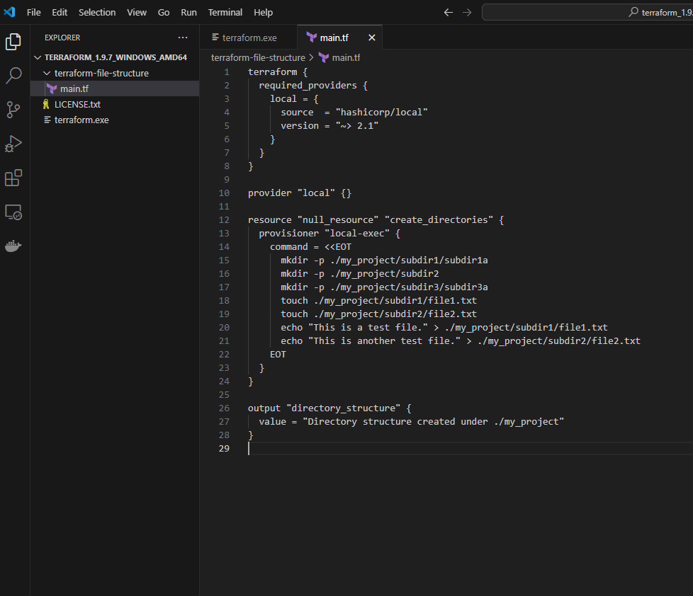

### **Step 3: Initialize Terraform**

In the terminal, run the following command to initialize Terraform:

terraform init

**Terraform not installed, even if it's installed, it asks for admin password-**

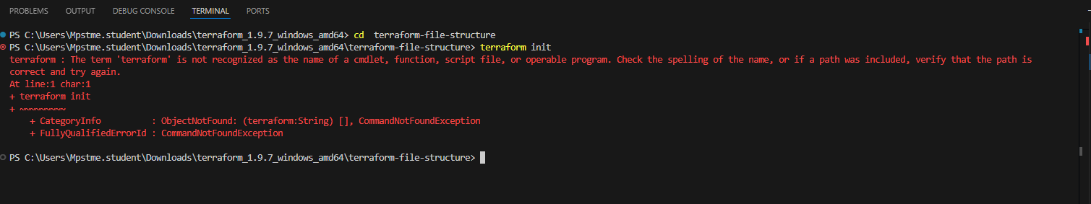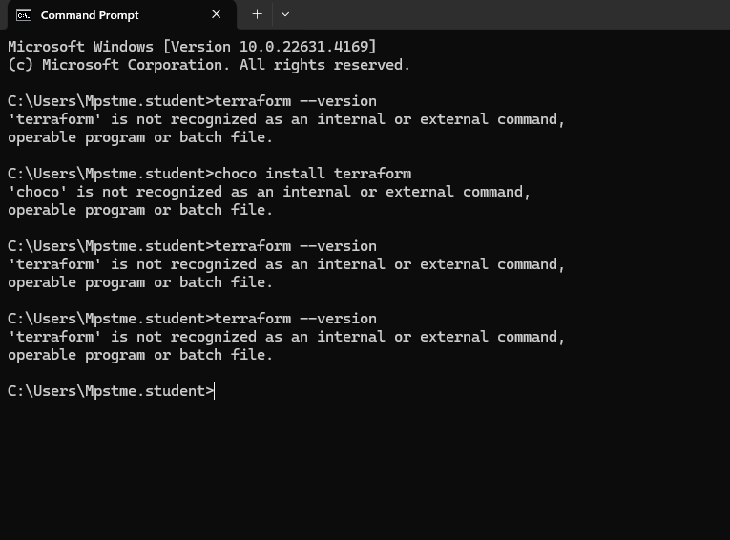

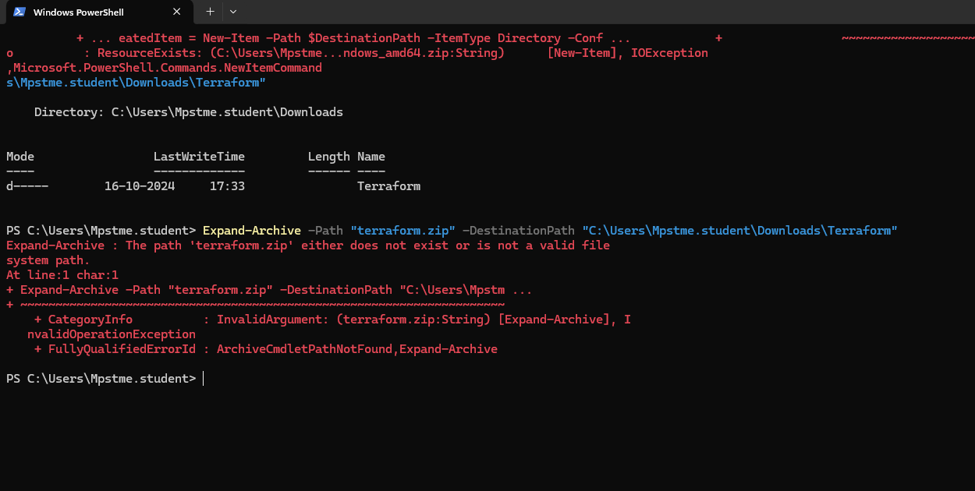

### **Step 4: Apply the Configuration**

Now, apply the Terraform configuration:

terraform apply

You'll be prompted to confirm the action. Type yes and press Enter.

### **Step 5: Verify the Structure**

After the command completes, you should see the created directory structure:

ls -R my_project

### **Step 6: Clean Up**

If you want to remove the created directories and files later, you can use:

terraform destroy

Again, type yes to confirm.